User Guide for TG EIEIO-MS/MS Predictor v1.1 Software or Excel prediction templates for Building TG CFID Spectral Library

# Guide for TG EIEIO-MS/MS Predictor v1.1 Software

The EIEIO-MS/MS Predictor v1.1 Software are optimized and designed to predict the EIEIO-MS/MS spectra and fast build a TG EIEIO MS/MS library based on systematic fragmentation pattern of TGs in EAD mode. Follow the steps below to utilized the software:

## EIEIO-MS/MS prediction for single TG molecule:

1. Double-click the software icon to open the main interface of the software.

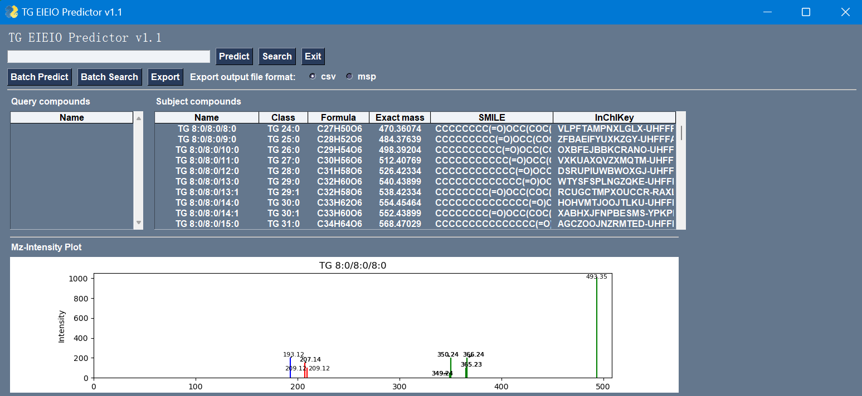

1. 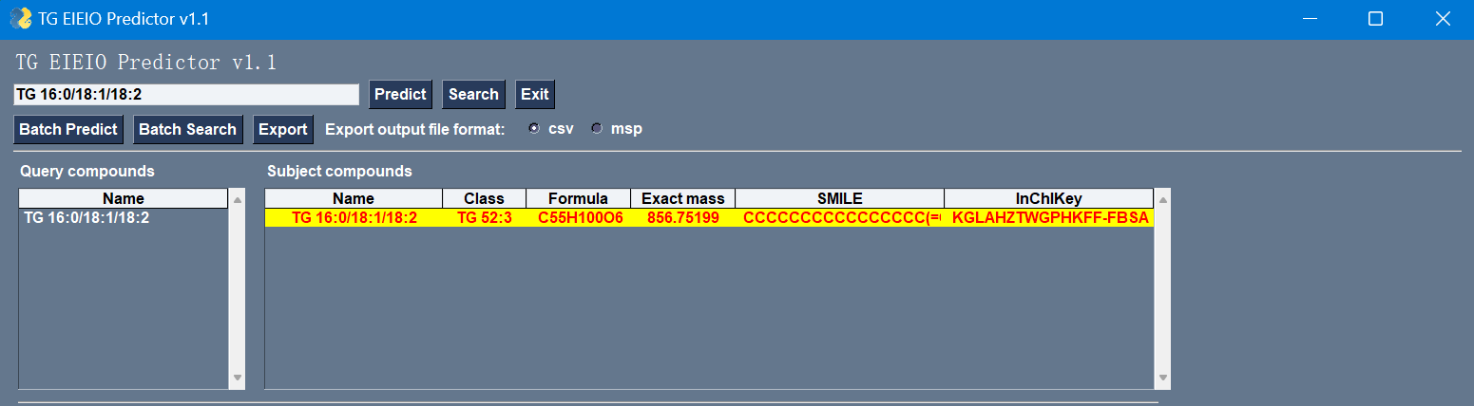Enter the name of the TG molecule you want to predict, e.g. “TG 16:0/18:1/18:2”.
2. By clicking on the Predict button, the sn fragments of the TG molecule will be automatically calculated, and the “Mz-Intensity”plot will be displayed when the EIEIO-MS/MS prediction is completed.

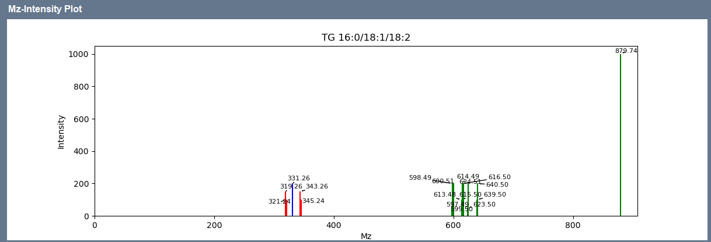

## Batch prediction of TG EIEIO MS/MS spectra.

1. Open the file “Demo list for TG batch prediction.csv” in the software folder, fill in the list of TG names to be predicted.

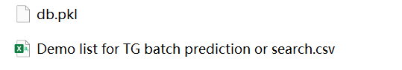

1. Double click to open the main interface of the software, and select the “Batch predict” button, the TGs will be displayed in the left windows, the TG information along with the EIEIO MS/MS spectra will be displayed in the right tab.

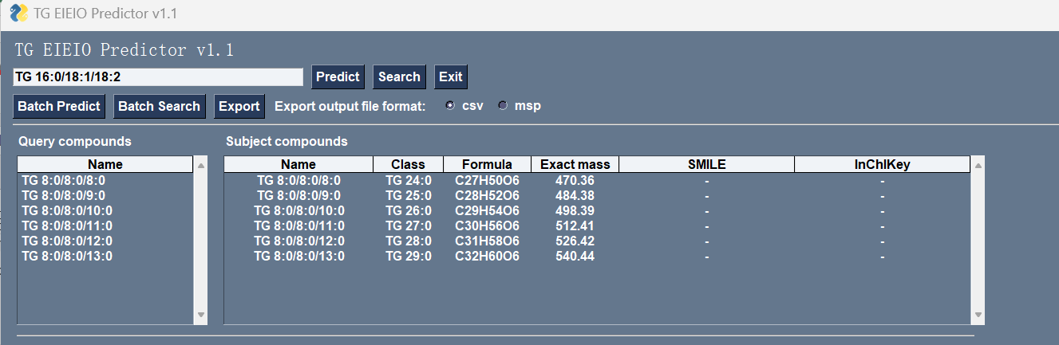

1. These predicted spectra can be able to be previewed in the plot below by clicking on the predicted TG entry information on the right.

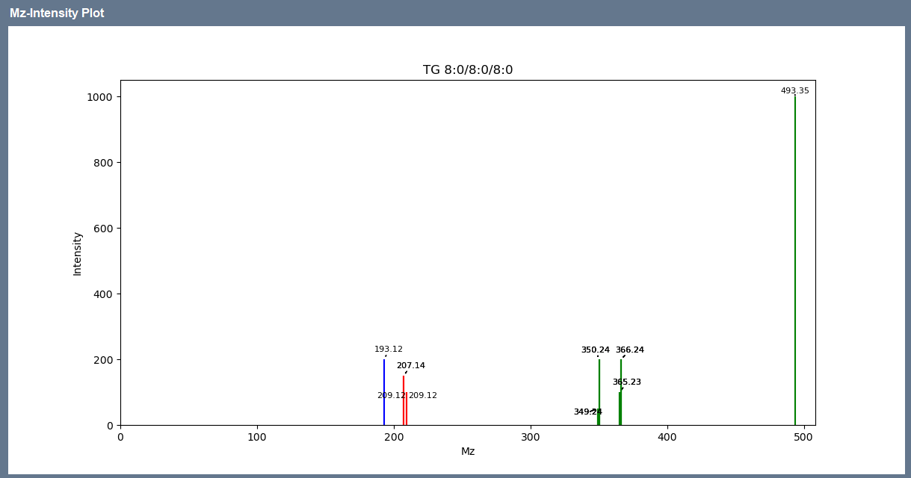

1. This predicted TG EIEIO-MS/MS information could be exported into .csv to further validate or .msp file to be directly used with the MS Dial.

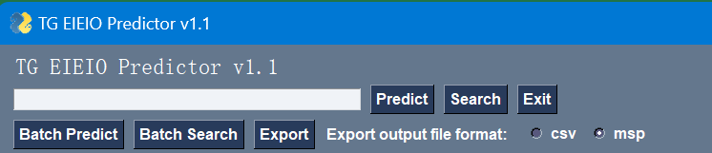

## CFID database search

1. For the convenience of researchers, the software has built-in EIEIO spectra of more than 57,000 TGs, allowing for direct retrieval and access to characteristic fragmentation ions information for rapid export and analysis.

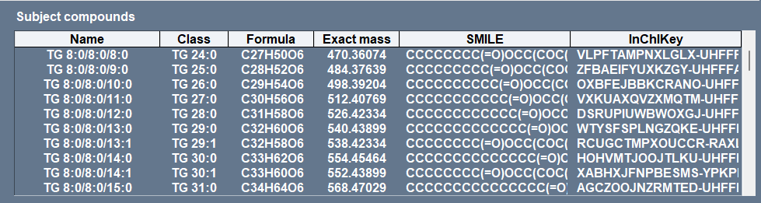

1. The software supports individual TG name retrieval and batch retrieval, the operation is the same as the above EIEIO-MS/MS prediction operation, and batch retrieval can be done by importing the retrieved TG list.
2. The built-in CFID database could be directly exported as an .msp file and used for the EIEO-M/MS annotation with MS Dial. Choose the export file format and output folder, click on “Ok”.

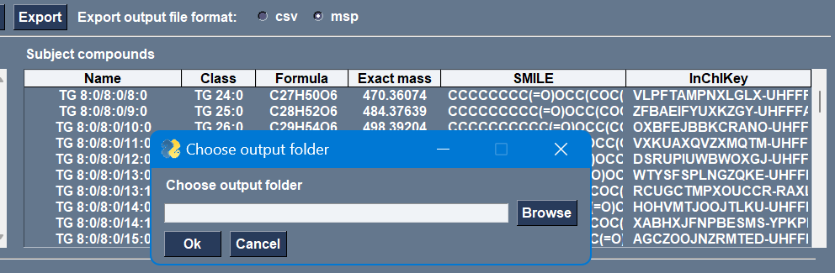

# User guide for Excel prediction templates.

To facilitate understanding of the principles of fragmentation prediction, we also provide an excel template for EIEIO MS/MS prediction, using which fragmentation prediction of TG molecules can also be easily performed. Excel templates contain 2 sheets, the sheet “sn fragment ions caculation” is designed to calculate the characteristic fragments ions for general fatty acyl chain, and already contains fragmentation information for 101 fatty acyl chains from FA 4:0 to FA 30:0. ; sheet “TG EIEIO-MSMS prediction” are mainly used to predict the EIEIO MS/MS spectra of TG species.

1. 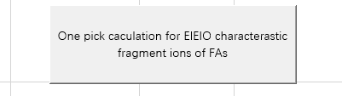**"Calculate characteristic fragments for newly added fatty acyls.** Fill in the new fatty acyl chains in the format of the example 'FA 30:0' and click the 'One-click calculation for EIEIO characteristic fragment ions of FAs' button to calculate the new fragment ions.
2. **EIEIO MS/MS prediction for TG species.** Fill in the new TG molecule in the named form of the example 'TG 16:0/18:1/18:2' and click the 'One-click for TG EIEIO MS/MS library prediction' button to predict the corresponding spectral library.

